Ideation Phase
Brainstorm & Idea Prioritization
Date | 20 FEB 2026
Team ID | LTVIP2026TMIDS78860
Project Name | Calculating Family Expenses Using ServiceNow
Maximum Marks | 4 Marks

Project Overview:
This guided project demonstrates how to build a basic, custom application on the ServiceNow platform to track, categorize, and report on family or personal expenses. It will leverage core ServiceNow functionalities, such as custom tables, forms, and reporting, to provide a centralized and structured system for budget management. The final solution will help users identify spending patterns and enforce budget limits.

Step-1: Team Gathering, Collaboration and Select the Problem Statement

Section | Description
PROBLEMS | * Family expenses are often tracked across disparate tools (spreadsheets, paper, banking apps), leading to fragmented data. * Difficulty in generating consolidated reports to identify monthly or annual spending trends. * Lack of a unified system to apply and track budget limits for different categories (e.g., groceries, utilities, entertainment).
DISCUSSION | The goal is to leverage ServiceNow's reliable database and reporting engine to create a simple, secure, and accessible single source of truth for all household financial data. This requires building a custom application with clear expense categories and automated reporting.
IDEAS | * Plan to create a custom table (u_family_expense) to store transaction details. * Define key fields: Date, Amount, Category (choice list), Paid By (reference to user), and Description. * Build a simple reporting dashboard to show spending by category month-over-month.
SOLUTIONS | * Develop and test the custom table and form layout. * Implement a simple monthly budget reporting feature (e.g., a report showing total spending vs. a fixed target value). * Deploy the application for family use and gather feedback for category refinement.
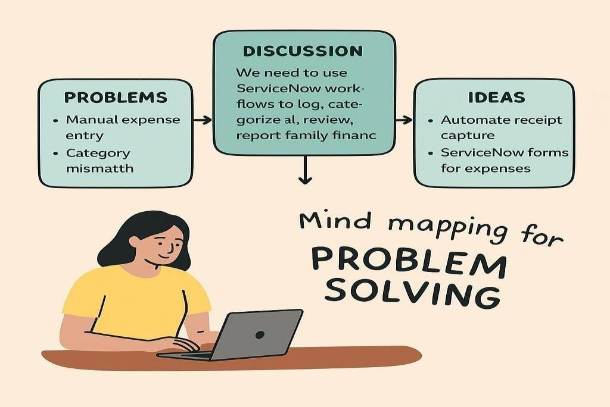

Step-2: Brainstorm, Idea Listing and Grouping Key Requirements & Ideas:
Feature | Idea Listing | Grouping | Action Planning
Data  Structure | Create a master table for  Expenses and a separate table for Categories (Food, Rent, Bills). | Database  Modeling | Define fields (Date,  Amount, Category, Description). Establish relationship between Expense and Category tables.
User  Experience | Design a simple, mobile- friendly input form for quick logging of new expenses. | User  Interface  (UI) | Use a simple form view. Implement mandatory fields (Amount, Date, Category).
Reporting | Build reports to calculate total spending per category. Add a gauge showing "Remaining Budget" based on a monthly target. | Analytics  &  Reporting | Create a Scheduled Report to email a weekly spending summary. Build a dashboard with Category donut charts.
Automation | Set up a Business Rule to flag transactions over a predefined "Large Expense  Threshold" (e.g.,  $500) as high-priority. | Platform  Logic | Write a simple Server- Side script (Business Rule) on insert/update of the expense table.
Step-3: Idea Prioritization
The main goal is to establish Data Integrity and provide Visual Clarity on spending.
Priority No. | Action | Core Goal
01 | Identify Core Expense Categories: Define a simple, necessary list (e.g., Housing, Groceries, Transportation) before building the table. | Maintain Data Integrity
02 | Lock Data Input: Ensure all necessary data (Amount, Category) is captured before saving. | Lock Deletion Actions  (Prevent incomplete data)
03 | Maintain Data Integrity: Use a Choice List or Reference Field for the Category field to ensure consistent spelling and grouping. | Maintain Data Integrity
04 | Notify Stakeholders: Set up a simple notification when an expense is logged (e.g., email confirmation). | Notify Administrators (Family Members)
05 | Provide Override Mechanism: Allow a  dedicated 'Admin' user (e.g., the primary budget holder) to modify or delete entries. | Provide Override Mechanism
06 | Sync Spending Status: Calculate a Monthly Total field dynamically based on all expenses logged so far. | Sync Incident Status (Sync Spending Status)
07 | Promote Sharing: Share the dashboard link with all family members for transparency. | Promote Sharing

Idea Prioritization:
Idea prioritization here helps us break down the custom application development into clear, functional components. We first focus on the database structure (u_family_expense table) to ensure reliable data storage. Only oncthee data is correctly structured do we move onto the reporting and automation layers. This approach ensures that the foundation of the budget tracker is robust before adding analytical features. Clear visual representations on the dashboard will simplify communication about financial health to all users.

